Project Information
Subrecipient or GLO Representative’s Name: |  |  |  | Contract No. and/or WO:
Applicant’s Name:
Co-Applicant’s Name:
Name of Person Claiming Disability (if different from Applicant or Co-Applicant):

Applicant’s Physical Address:
City: |  | State: Texas |  | Zip Code:
Instructions
In order to render assistance targeted to program applicants or other persons claiming disability/special needs, the GLO must verify the applicant's status. There are three methods of verification, depending upon whether the disability/special need is obvious or requires certification from a medical professional, or whether the disabled/special needs person receives disability-related federal benefits. Please proceed to the section below that corresponds to the circumstances of the applicant or other person claiming disability/special needs named above.
Disability (Choose ONE)
☐ 1. Obvious Disability:
Check this box if, in the reasonable judgment of the GLO representative, the person named above has an obvious disability/special need. Examples of obvious disability/special need are blindness or permanent necessity of wheelchair use. No further verification of disability/special needs is required.

☐ 2. Receipt of Federal Disability Benefits:
Check this box if the person named above receives disability-related Social Security ("SSDI"), Supplemental Security Income ("SSI"), Veterans' Administration ("VA"), or other federal benefits. Subrecipient must be able to verify current benefits through reasonable documentation that may include a benefit verification letter from the federal agency involved, canceled checks or direct deposit documents, a completed CDBG-DR Program Form 14.10 ("Verification of Social Security Benefits") showing receipt of SSDI or disability-related SSI benefits, or like records. No further verification of disability/special needs is required.

Type of Documentation Provided:

☐ 3. Certification of a Medical Professional:
Check this box if the person named above does not have an obvious disability/special need and does not receive disability-related federal benefits. In such circumstances, disability/special needs status can only be verified through certification by a medical professional. The GLO representative must obtain such certification as directed below.

To the applicant and/or person claiming disability:
The undersigned medical professional has knowledge of whether the claimed disability meets the definition applicable to this verification so that you or your household may qualify for housing assistance under the GLO Disaster Recovery Program. YOU ARE NOT OBLIGATED TO CONSENT TO THE RELEASE OF THIS INFORMATION. However, the GLO representative must receive the information requested from the medical professional to determine any applicable construction accommodations. The GLO or its representative may request from the medical professional only the minimum information necessary to determine whether the applicable definition of disability has been met.

I hereby authorize the release of the requested information to the GLO representative.
Name of Authorized Person: | Signature of Authorized Person: | Date:

To the medical professional whose certification of disability is requested below:
The GLO has a contractual obligation with the United States Department of Housing and Urban Development Community Development Block Grant Disaster Recovery Program (“Program”) to verify disability when providing housing assistance. The Applicant has asserted that he/she, or the member of his/her household named above, has a disability which must be documented by a medical professional. An authorized individual has lawfully consented to release to the GLO the medical opinion below regarding the claimed disability. All information provided by a medical professional will be used solely to establish disability status. Neither the GLO nor its representatives may ask about the nature of an individual's disability, and medical professionals should not disclose specific details or diagnoses.

I hereby certify that, in my opinion, the disability claimed by the above-named applicant or person claiming disability ☐Does ☐Does Not meet the definition of disability set forth in this verification.
Signature of Medical Professional: | Title and Organization: | Date:

Construction Accommodations
This section is used in certain applications to specify construction accommodations necessary to provide for the disabled individual's long-term needs. The Applicant is requested to return this form to the GLO or its representatives during the consultation to determine eligibility and level of housing benefits.

Please read below and place an “X” in the applicable box that accurately describes the person listed
above and his/her accessibility needs.
1) By default, Applicant will receive Standard Tub/Shower without grab bars unless this sheet specifies otherwise. So please review the Accessible Bath Style Options and mark the single best option that assists the disabled person. Note: Per the GLO Construction Manual, accessible features will be designed and constructed to the ADA 2010 Standards, with HUD exceptions, unless otherwise specified by the applicant through a reasonable accommodation. NOTE: Options HC-3 and HC-4 can also include an accessible vanity, as well as accessible kitchen features (if requested).
☐ HC-2 Tub/Shower with Blocking & Grab Bar  (Non-ADA Compliant) | ☐ HC-3 Tub/Shower with Blocking, Grab Bars,  Fold-up Seat, Shower Wand (ADA Compliant) |  | ☐ HC-4 Roll-In Shower with Grab Bars, Fold-up Seat, Shower Wand (ADA Compliant) |  | ☐ N/A-Standard Tub/Shower
2) By default, the HC selection marked above will be installed in the Master Bathroom. If the Applicant needs the HC selection installed in a different bathroom, please mark the box and specify the preferred bathroom.

☐ HC Selection to be installed in the following bathroom:
3) Additional Accommodations (Mark only the options that apply):

Note: All standard and HC selected bathrooms will have toilet seats that are elevated to ADA standards. All dwellings will have no-step access meaning either a ramp or lift will be installed if elevated.
☐ Vinyl Flooring  (No Carpet) | ☐ Dishwasher |  | ☐ Visually  Impaired |  | ☐ Hearing Impaired
4) Provide explanation for selections made above or any additional special needs that may apply:

Signatures
Under penalties of perjury, I certify that the information presented in this document is true and accurate to the best of my knowledge and belief. I further understand that providing false representations herein constitutes an act of fraud. False, misleading or incomplete information may result in my ineligibility to participate in Programs that will accept this Document. Warning: Any person who knowingly makes a false claim or statement to HUD may be subject to civil or criminal penalties under 18 U.S.C. 287, 1001 and 31 U.S.C. 3729.
Subrecipient or GLO Representative’s Name: |  |  | Date:
Subrecipient or GLO Representative’s Signature:
Applicant’s Printed Name: |  |  | Date:
Applicant’s Signature:
Co-Applicant’s Printed Name: |  |  | Date:
Co-Applicant’s Signature:

Accessible Bath Style Options*
*Final design, color, or layout of amenities may vary from those shown below. HC designates “Handicap” options.

HC–2 Tub/Shower with Blocking & Grab Bar (Non-ADA Compliant)  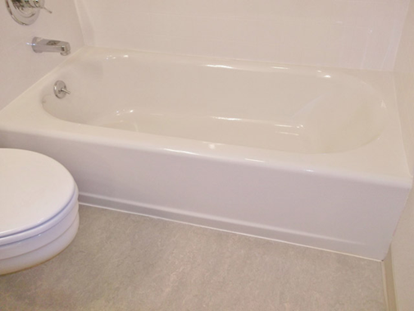  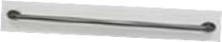 | HC–3 Tub/Shower with Blocking, Grab Bars, Fold-up Seat, and Shower Wand (ADA Compliant)  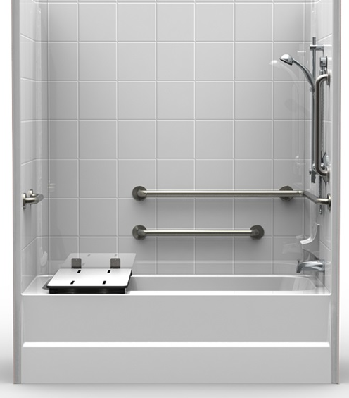
HC–4 Roll-In Shower with Grab Bars, Fold-up Seat, and Shower Wand (ADA Compliant) | NOTE: Options HC-3 and HC-4 can also include an accessible vanity, as well as accessible kitchen features (if requested).

