Texas General Land Office
Community Development and Revitalization
Damage Assessment Guidelines

Lead Department:

Community Development and Revitalization (CDR)

Purpose:
Damage Assessment Guidelines (Single Family Housing)

Summary:
The Texas General Land Office (GLO) has established Damage Assessment requirements that Subrecipients or the State Representatives providing disaster recovery assistance must follow.

Subrecipient Instructions:
- The damage inspector will be required to specifically and clearly document storm related property damage via photographic evidence and detailed narratives (samples attached).
- The narratives should fully describe the damage in the photograph and verify the damage was storm related.
- A front elevation picture in the damage assessment is acceptable as a way of documenting the assessed structure.
- Other documentation or pictures taken for purposes other than to document damage should be kept separately from the damage assessment report.
The Subrecipient or the State’s Representative should maintain damage assessment documents as part of their applicant file as they assist in supporting eligibility. The GLO guidance should not be used as the only review when considering compliance with HUD standards. Each Subrecipient and State Representative is highly encouraged to document internal processes to ensure compliance.

Project I.D. | Inspection Date | Evidence of Storm Damage | Photographic Evidence of Storm Damage
XXXXXXXXXX | XX-XX-XXXX | Applicant: Home received 2- 3 feet of water from the storm surge causing damage to the walls, floors, doors, cabinetry, appliances, electrical, and plumbing system. In addition, strong winds damaged the roof covering which allowed rain water to enter home and damage some of the ceilings, walls, and floors.  DCT Inspector: Exterior: roofing, siding and piers; Interior: Floors, walls, ceilings and electrical.  ECR Inspector: Siding, roof, fascia/soffit, foundation and piers are damaged. Drywall is damaged or has poor workmanship. Sub floor is damaged in all rooms and flooring is damaged in most of the rooms. | 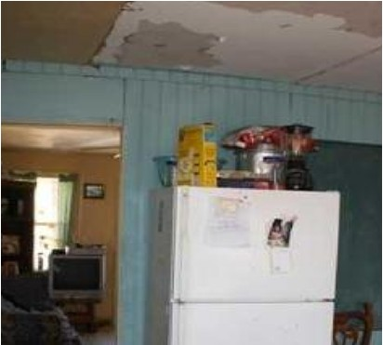 | 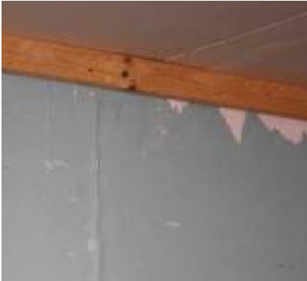
XXXXXXXXXX | XX-XX-XXXX | Applicant: The roof covering was damaged by wind and has not been replaced. Water entered through  the roof damaging ceilings, walls and flooring. The area beneath the home received 2-3 feet of water from the storm surge which caused damage to some of the electrical and plumbing components.  DCT Inspector: Exterior wind and rain damage. Interior water damage (flooring, walls and windows).  ECR Inspector: Hurricane damage- roofing; water damage to interior ceilings, walls and floors. | 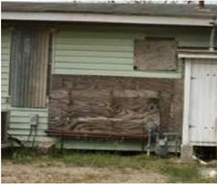 | 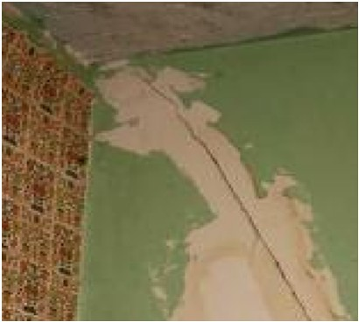
XXXXXXXXXX | XX-XX-XXXX  SAMPLE | Applicant: N/A; this is a mobile home 11.01A.  DCT Inspector: App States H20 entered through vent making floors warp and water stained ceiling.  ECR Inspector: Damage from the event was observed on the site. Photographic evidence documents broken and cracked windows, interior ceiling damage, and damaged roofing. | 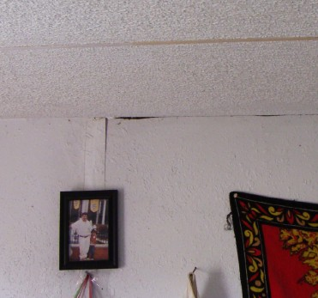 | 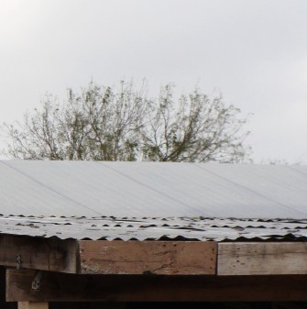
XXXXXXXXXX | XX/XX/XXXX | Applicant: N/A, this is a mobile home 11.01A.  DCT Inspector: Ext: roof, leveling, bottom floor board and insulation; Interior: ceiling, walls and floors.  ECR Inspector: Due to the extent of the storm damage from the event coupled with HQS and code violations, the cost of repair for this structure is over the program rehabilitation cap. Therefore, a reconstruction is recommended. Photographic evidence of interior ceiling damage from roof leak. | 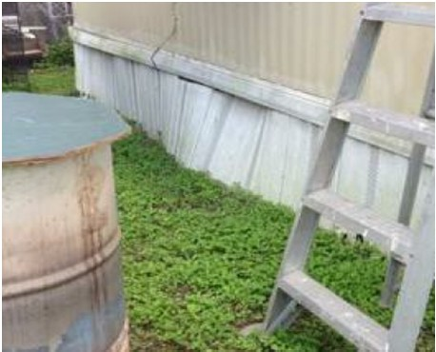 | 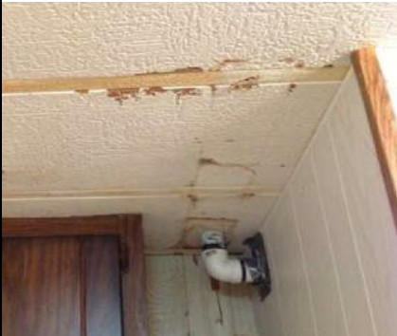

Activity Number | Inspection Date | Evidence of Storm Damage | Photographic Evidence of Storm Damage
XXXXXXXXXX | XX-XX-XXXX | Applicant: N/A, this is a mobile home 11.01A.  DCT Inspector: Exterior: roof, leveling, bottom floor board and insulation; Interior: ceiling, walls and floors.  ECR Inspector: Due to the extent of the storm damage from the event coupled with HQS and code violations, the cost of repair for this structure is over the program rehabilitation cap. Therefore, a reconstruction is recommended. Photographic evidence of interior ceiling damage from roof leak. | 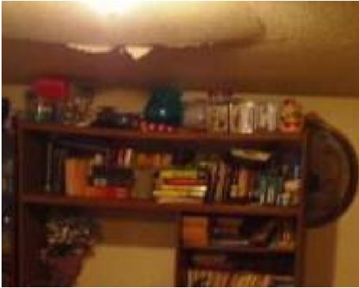 | 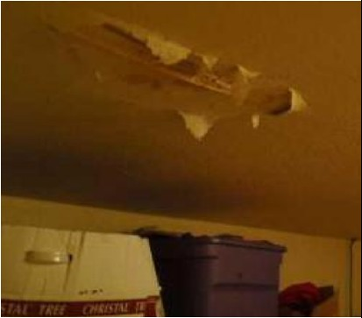
XXXXXXXXXX | XX-XX-XXXX | Applicant: Strong winds damaged the roof covering which allowed rain water to enter and cause damage to some of the ceilings, walls, and floors.  SAMPLE  DCT Inspector: Interior: ceiling, walls and floors. Ext: roof, siding and piers.  ECR Inspector: The roof is damaged and some siding is damaged or missing. Some ceilings and walls have water damage. | 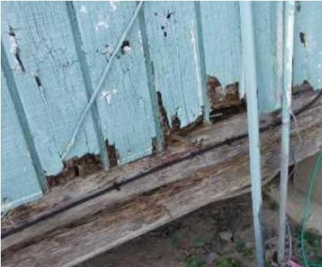 | 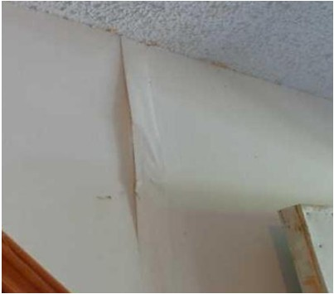
XXXXXXXXXX | XX-XX-XXXX  SAMPLE | Applicant: Strong winds damaged the roof covering which allowed rain water to enter home and cause damage to some of the ceilings, walls, and floors.  DCT Inspector: Exterior: roof, siding and piers; Interior: ceiling, walls and floors.  ECR Inspector: Roof is damaged. Some ceilings have water damage. | 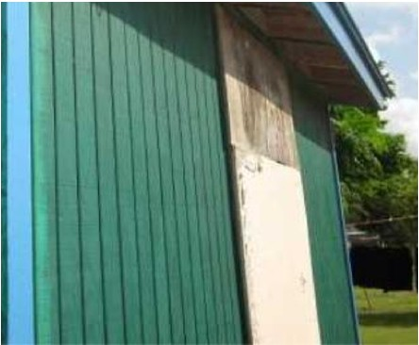 | 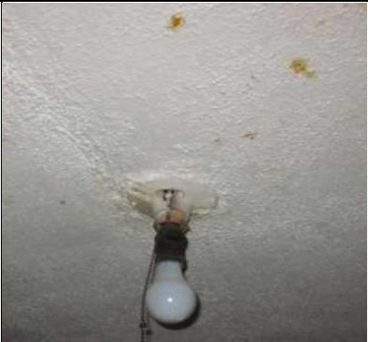
XXXXXXXXXX | XX-XX-XXXX | Applicant: The home received 2 feet of water which caused damage to the walls and floor. Strong winds damaged the roof covering which allowed rain water to enter home and cause damage to some of the ceilings, walls, and floors.  DCT Inspector: Exterior: roof, siding and piers; Interior: ceiling, walls and floors.  ECR Inspector: Roof is damaged. Some ceilings and walls are damaged. | 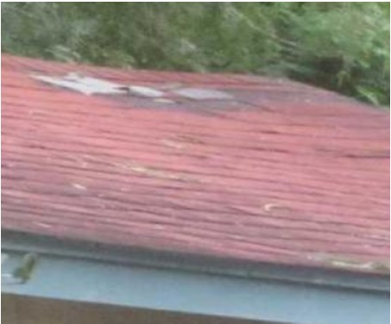 | 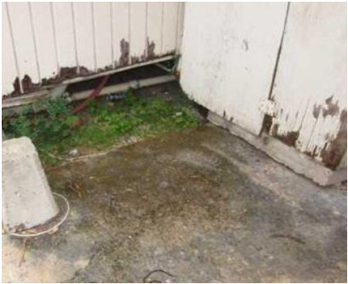

Activity Number | Inspection Date | Evidence of Storm Damage | Photographic Evidence of Storm Damage
XXXXXXXXXX | XX-XX-XXXX | Applicant: Strong winds damaged the roof covering which allowed rain water to enter home and cause damage; unable to get photo of exterior damage due to lattice being in the way.  ECR Inspector: The roof was never replaced after the storm and there is evidence of repaired leaks and possible new leaks in some ceilings. Even though some ceilings and floors were replaced the workmanship was poor. | 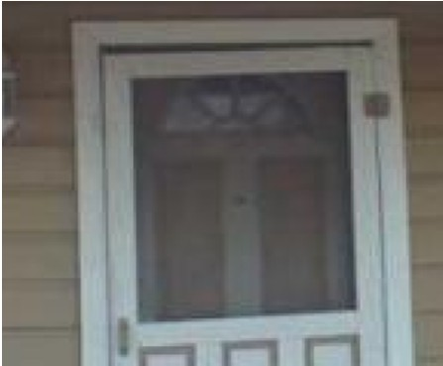 | 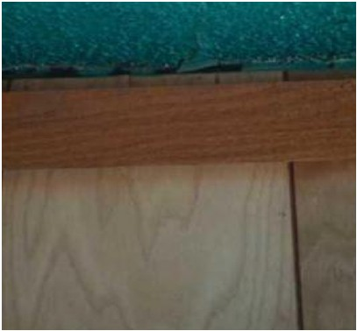
XXXXXXXXXX | XX-XX-XXXX | Applicant: The area beneath the home received several feet of flood water which caused damage to the foundation and subfloor. Strong winds also damaged the roof covering which allowed rain water to enter the home and cause damage to some of the ceilings and walls.  DCT Inspector: Applicant advised that he noticed house was shifting two years ago. Interior: cracks on ceiling and walls. Floor is buckling.  ECR Inspector: Some cracking in the stucco. Some ceilings and walls have water damage. The flooring is damaged. | 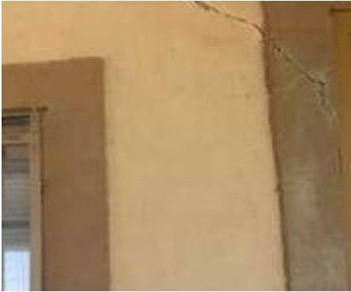 | 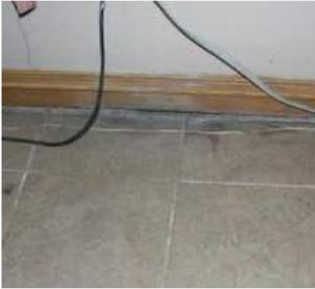
XXXXXXXXXX | XX-XX-XXXX | Applicant: Strong winds damaged the roof covering which allowed rain water to enter the home and cause damage to some of the ceilings and walls.  SAMPLE  DCT Inspector: Interior: small area of ceiling and wall in laundry room is damaged; Exterior: none.  ECR Inspector: Ceiling is damaged in Laundry Room | 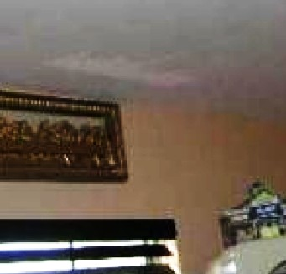 | 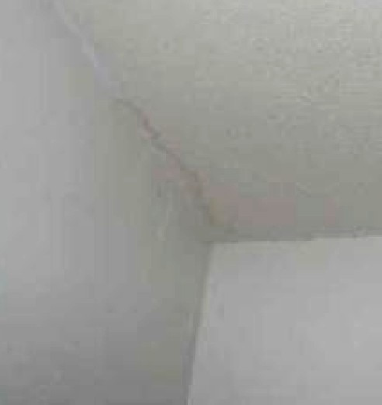
XXXXXXXXXX | XX-XX-XXXX | Applicant: The area beneath the home received 1-2 feet of water from the storm surge which caused damage to some of the electrical components. Strong winds also damaged the roof covering which allowed rain water to enter the home and cause damage to some of the ceilings and walls.  DCT Inspector: Exterior: piers and roofing; Interior: ceiling, walls and floors.  ECR Inspector: Roof is damaged. Wood siding is damaged or missing. Some of the fascia is damaged. The ceiling and walls are damaged in some of the rooms. The subflooring needs to be replaced. | 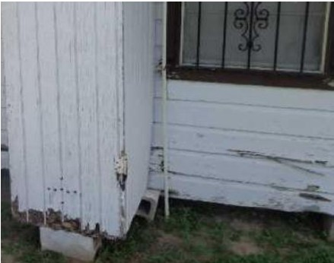 | 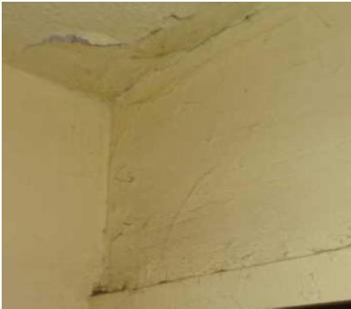
203400006

